**DASCH Plug-In for VStar**

DASCHObservationSource is a VStar observation source plug-in tool which reads DASCH (Digital Access to a Sky Century @ Harvard) data from an input source in tab-delimited “Starbase table” (.txt)) format. See bugs-and-features #439 on SourceForge for VStar. More information is available at <http://dasch.rc.fas.harvard.edu/project.php>.

Install the DASCH plug-in by going to the *Tool* menu and selecting *Plug-in Manager*. AAVSO login is required. Scroll to and select DASCH file reader and click on Install. After installation, restart VStar.

To obtain a DASCH data file, go to the web page <http://dasch.rc.fas.harvard.edu/lightcurve.php>

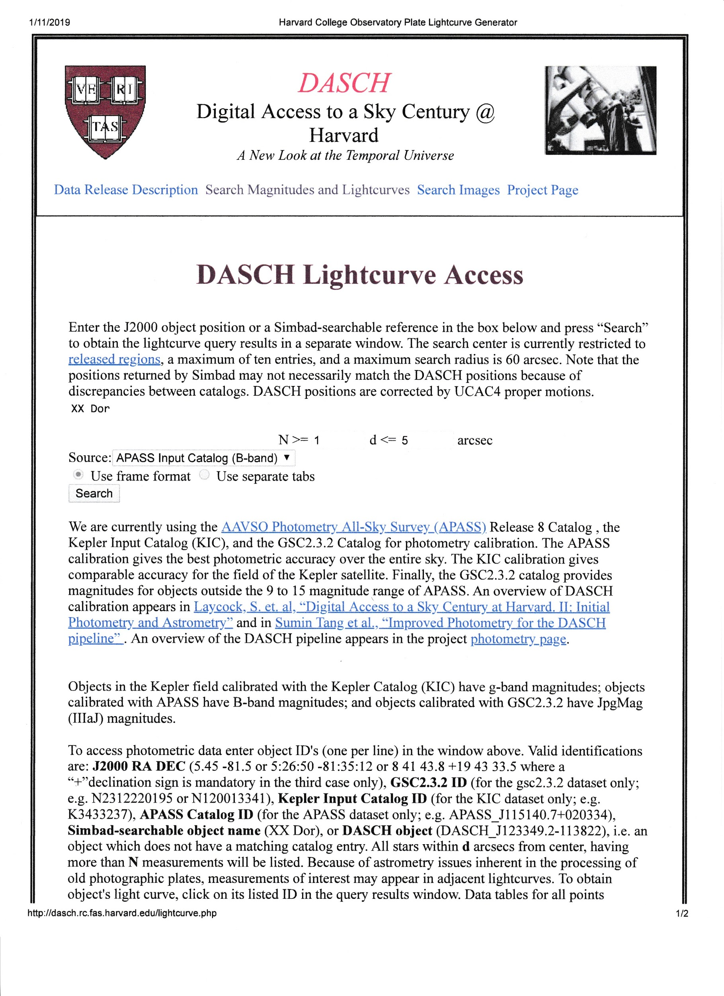

Enter a J2000 object position or a SIMBAD-searchable reference in the box and press “Search” to deliver the query results in a separate window.

As an example, entering "XX Dor” tells the search facility to search for variable stars using the APASS Input Catalog (B-band) for that object. Other catalogs include the Kepler Input Catalog (KIC), DASCH object, and GSC2.3.2 catalog. Additionally, J2000 RA/DEC coordinates (e.g., 8 41 43.8 +19 43 33.5) are valid identifications. The resulting window containing three frames is produced.

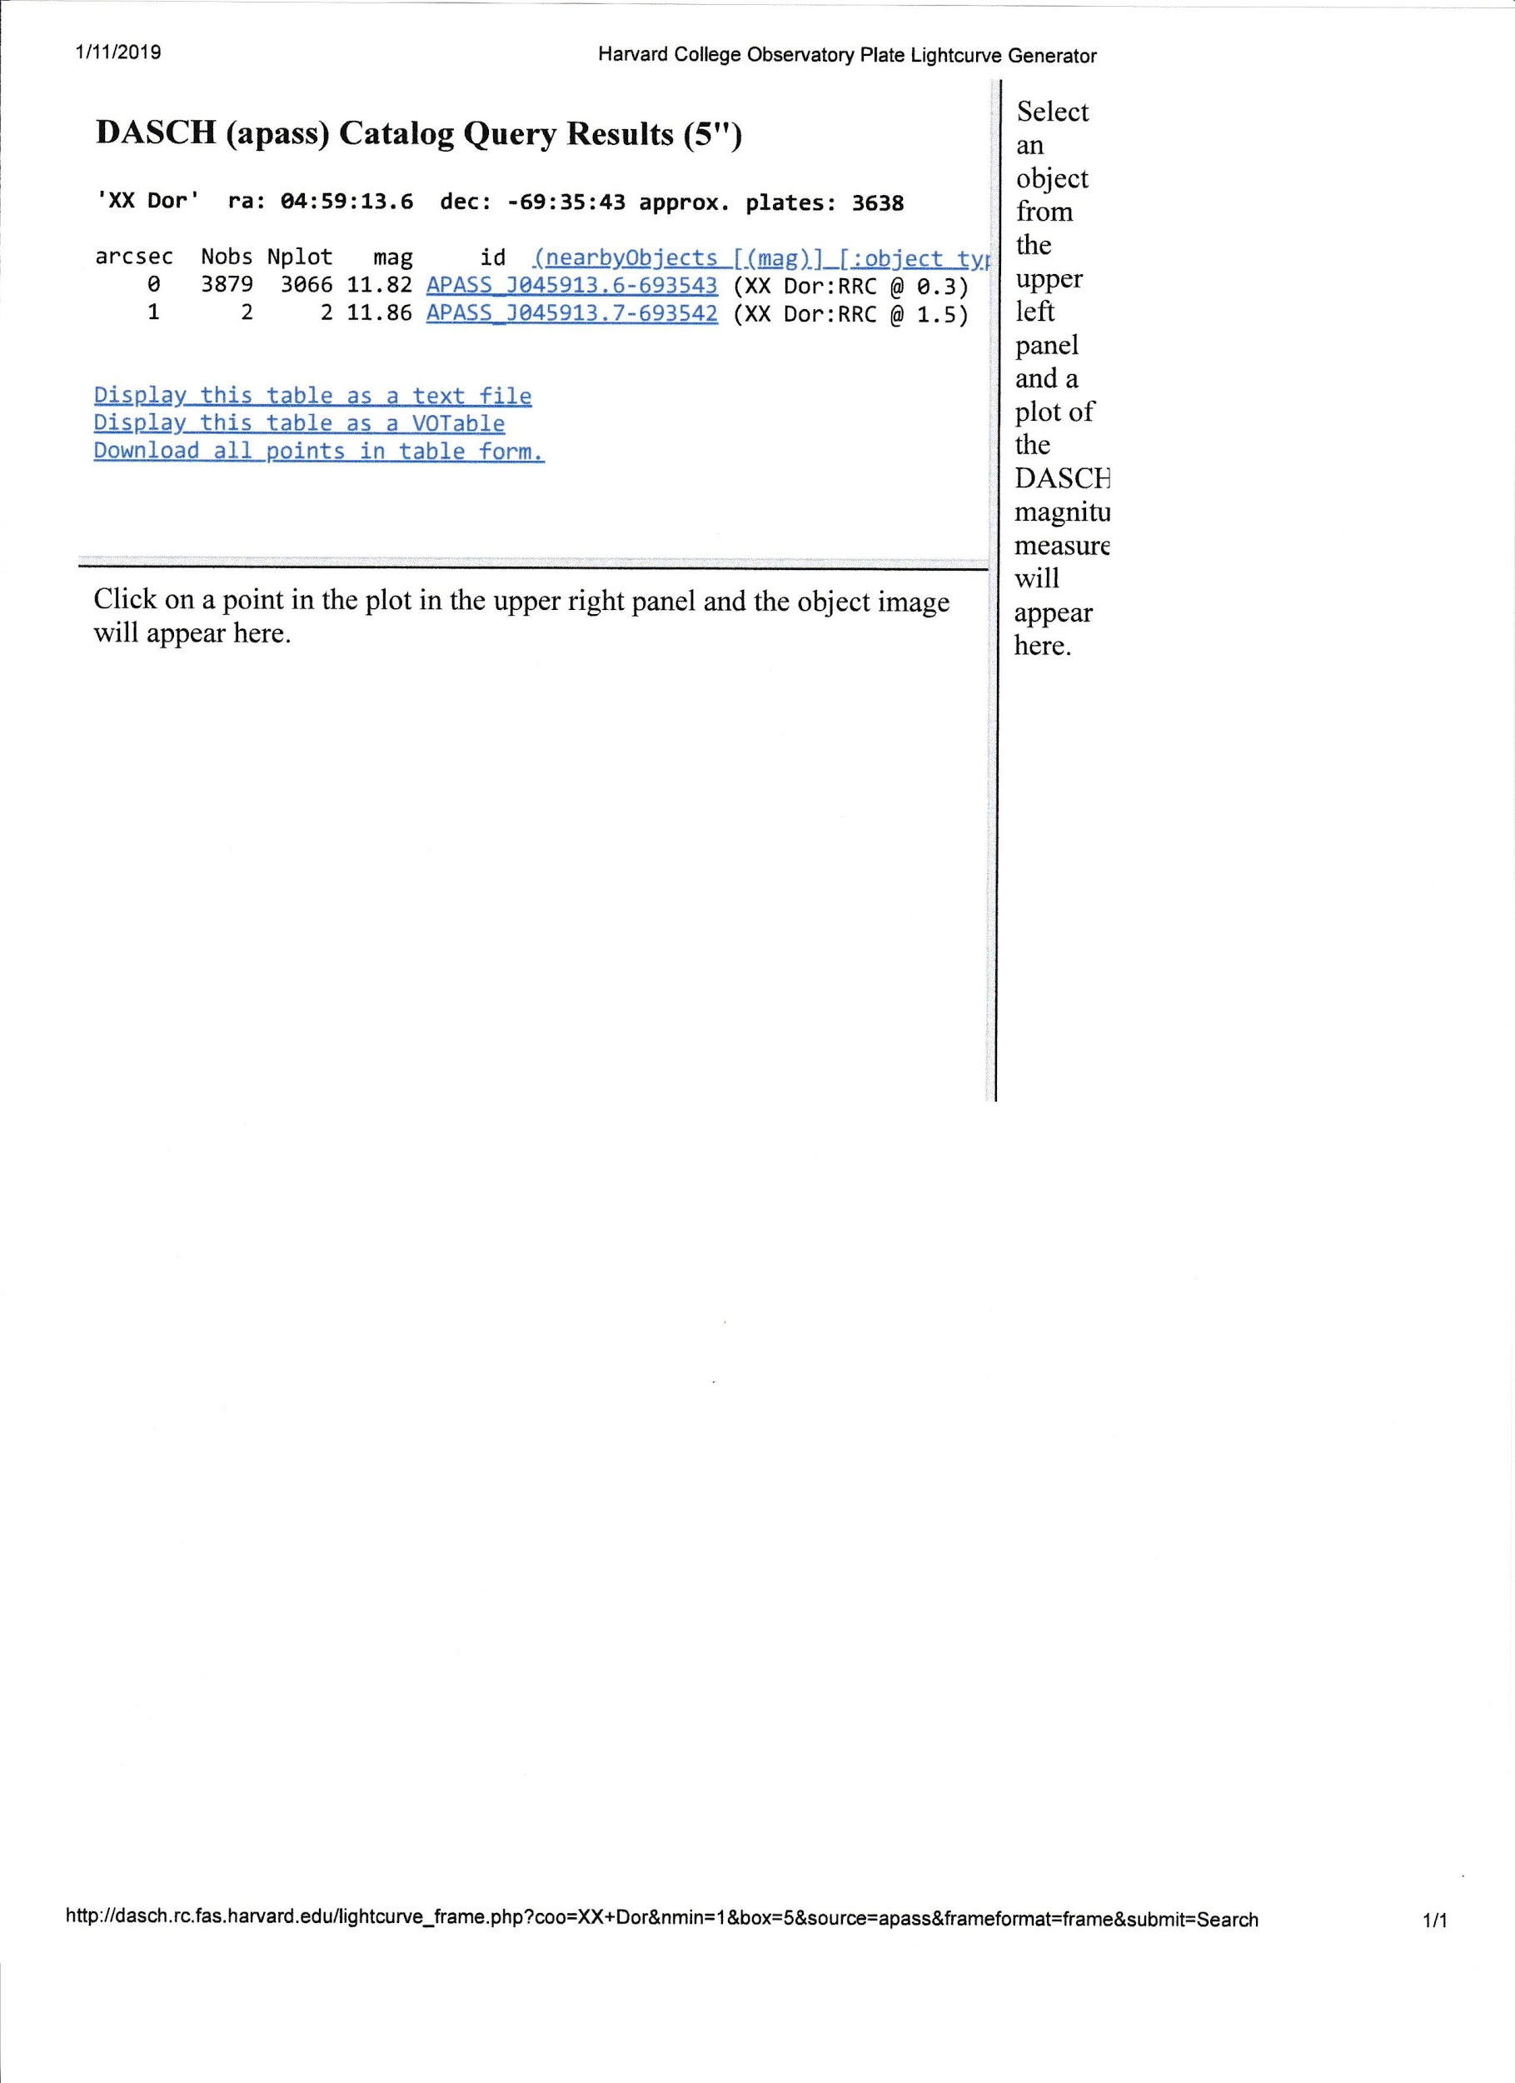

In the top left hand frame, three sets of results and some display / download options are shown. Choose the option “Download all points in table form”, and the resultant page lists several file options (A - H) for each of the three result sets.

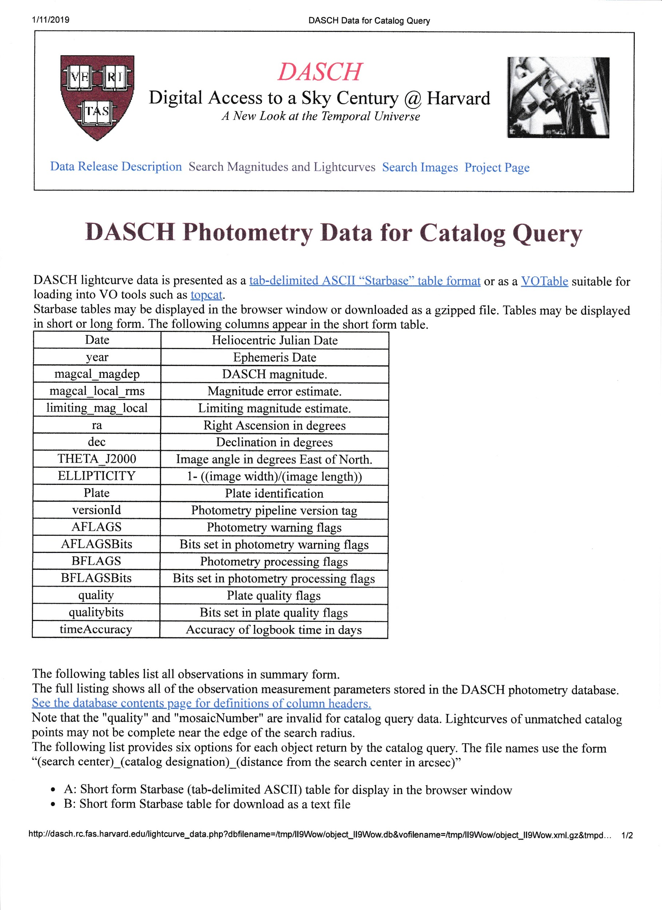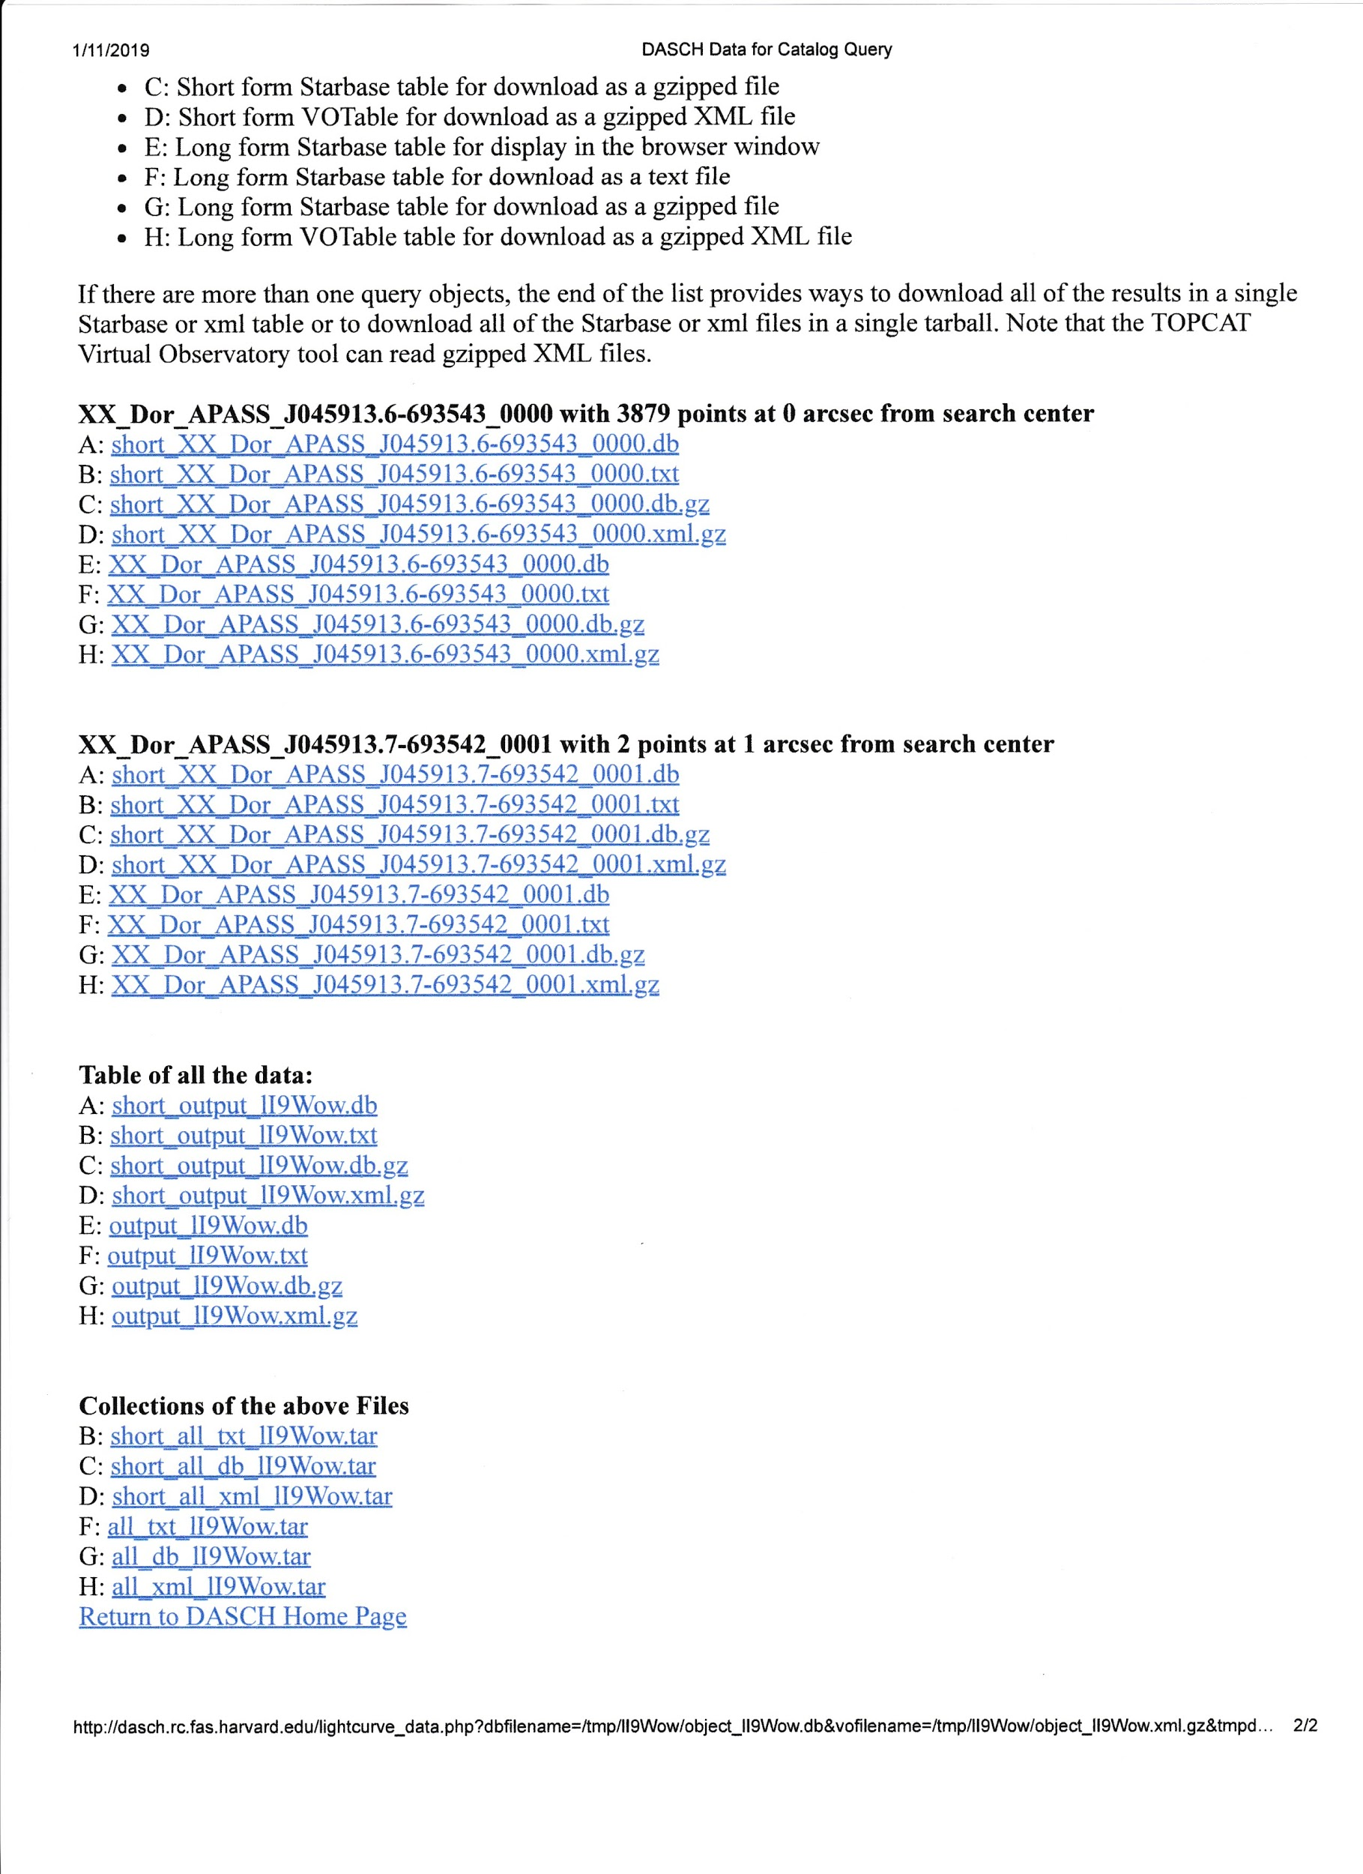

This plug-in is designed to read files of type A, such as “short_XX_Dor_APASS_J045913.6-693543_0000.db".

The plug-in can read this either as a local file on your PC or Mac (once you download it), or as the appropriate URL, in this case:

http:// dasch.rc.fas.harvard.edu/tmp/rv1tC9/short_XX_Dor_APASS_J045913.6-693543_0000.db.

Note that these URLs are available only on a temporary basis. Other instances of the same query may produce a different URL. Downloading a file to your PC looks like:

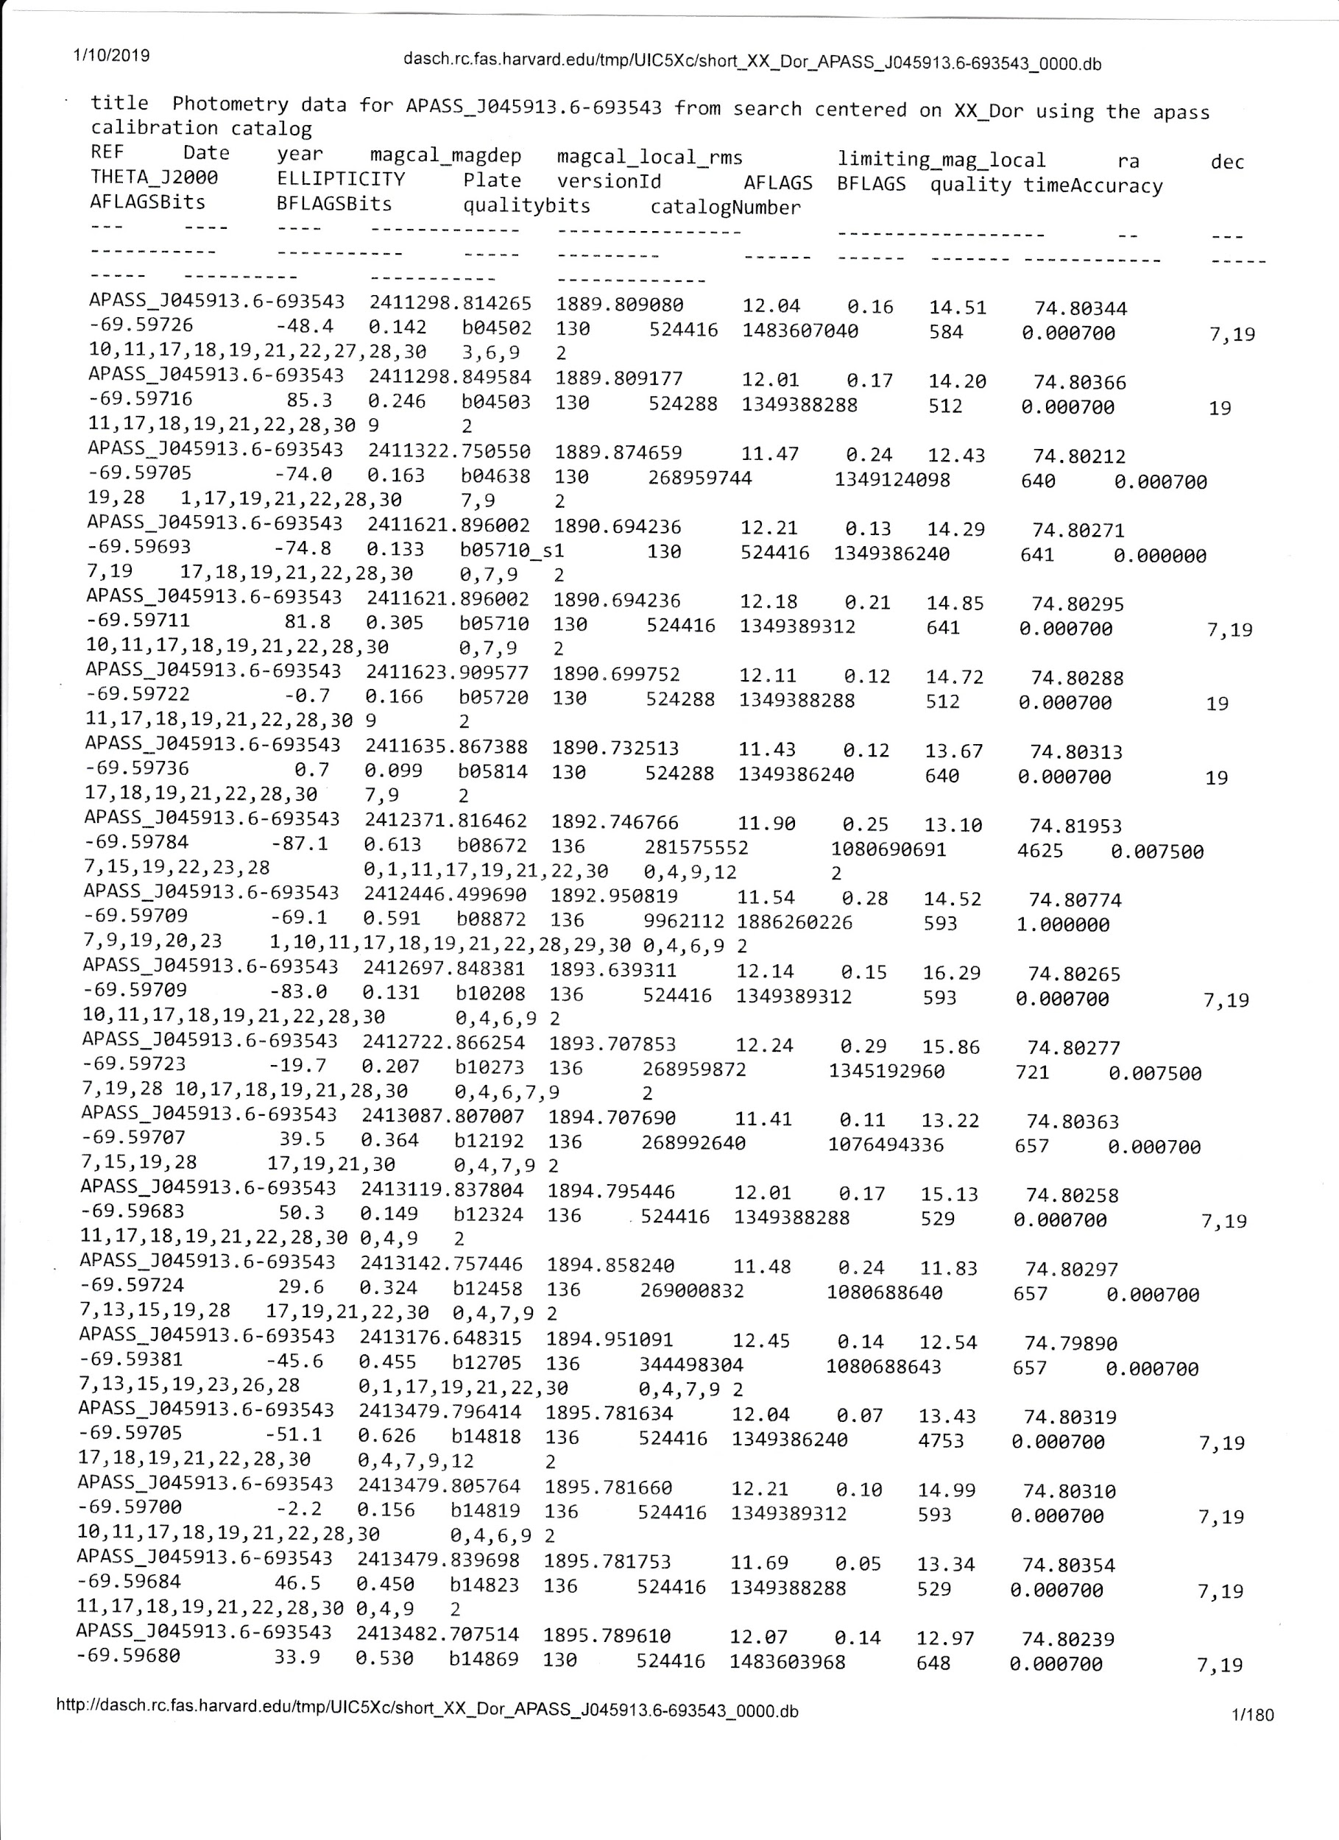

In VStar, to use this plugin, select “New Star from DASCH file …” from the *File* menu. The plugin will display a dialog box, asking you to select a file or input a full URL. The DASCH data will then become available in VStar for analysis.

In the DASCH data, some of the observations show a “magErr” of 99, indicating that the observed magnitude lies beyond the range of the limiting magnitudes for the original plates. The plug-in flags these observations as “excluded. For the above example, the initial plot looks like the following, somewhat distorted by the resultant large error bars.

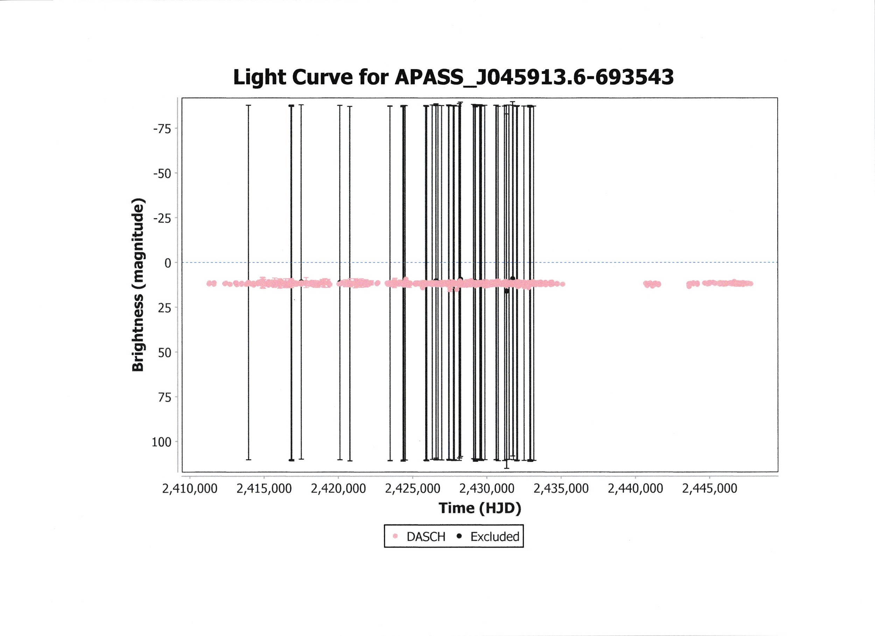

If you then select *Plot Control* from the *View* menu and un-check the “Excluded” box under Visibility of Data, the new plot will look much more “reasonable”.

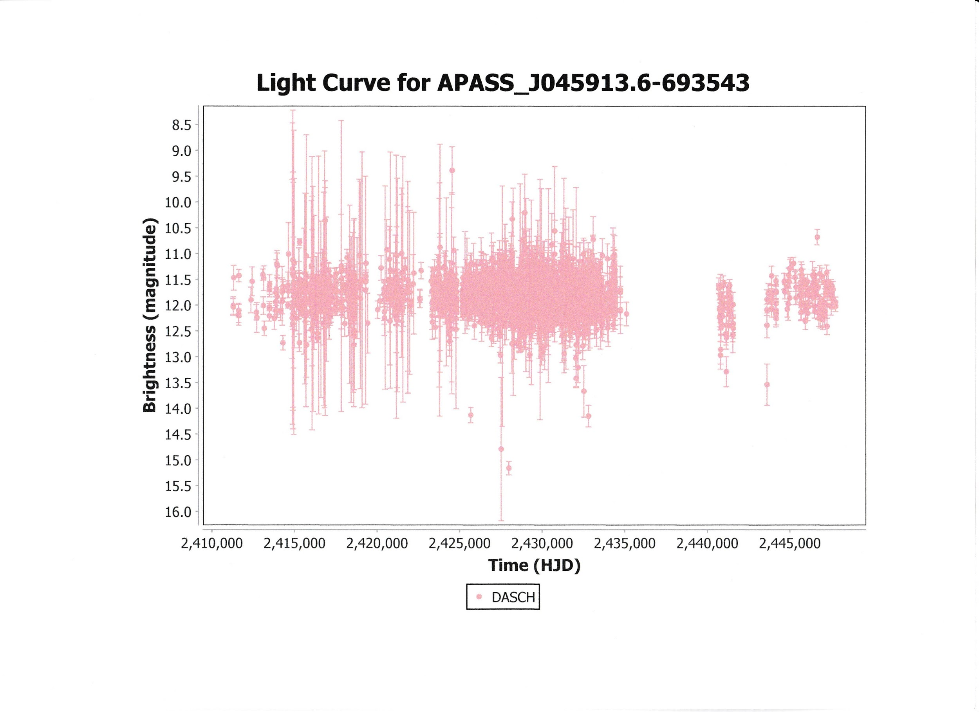

From there, a variety of analyses is available in VStar. For example, if period analysis is desired, go to the VStar *Analysis* drop down menu and select “DC DFT Standard Scan”. This will yield:

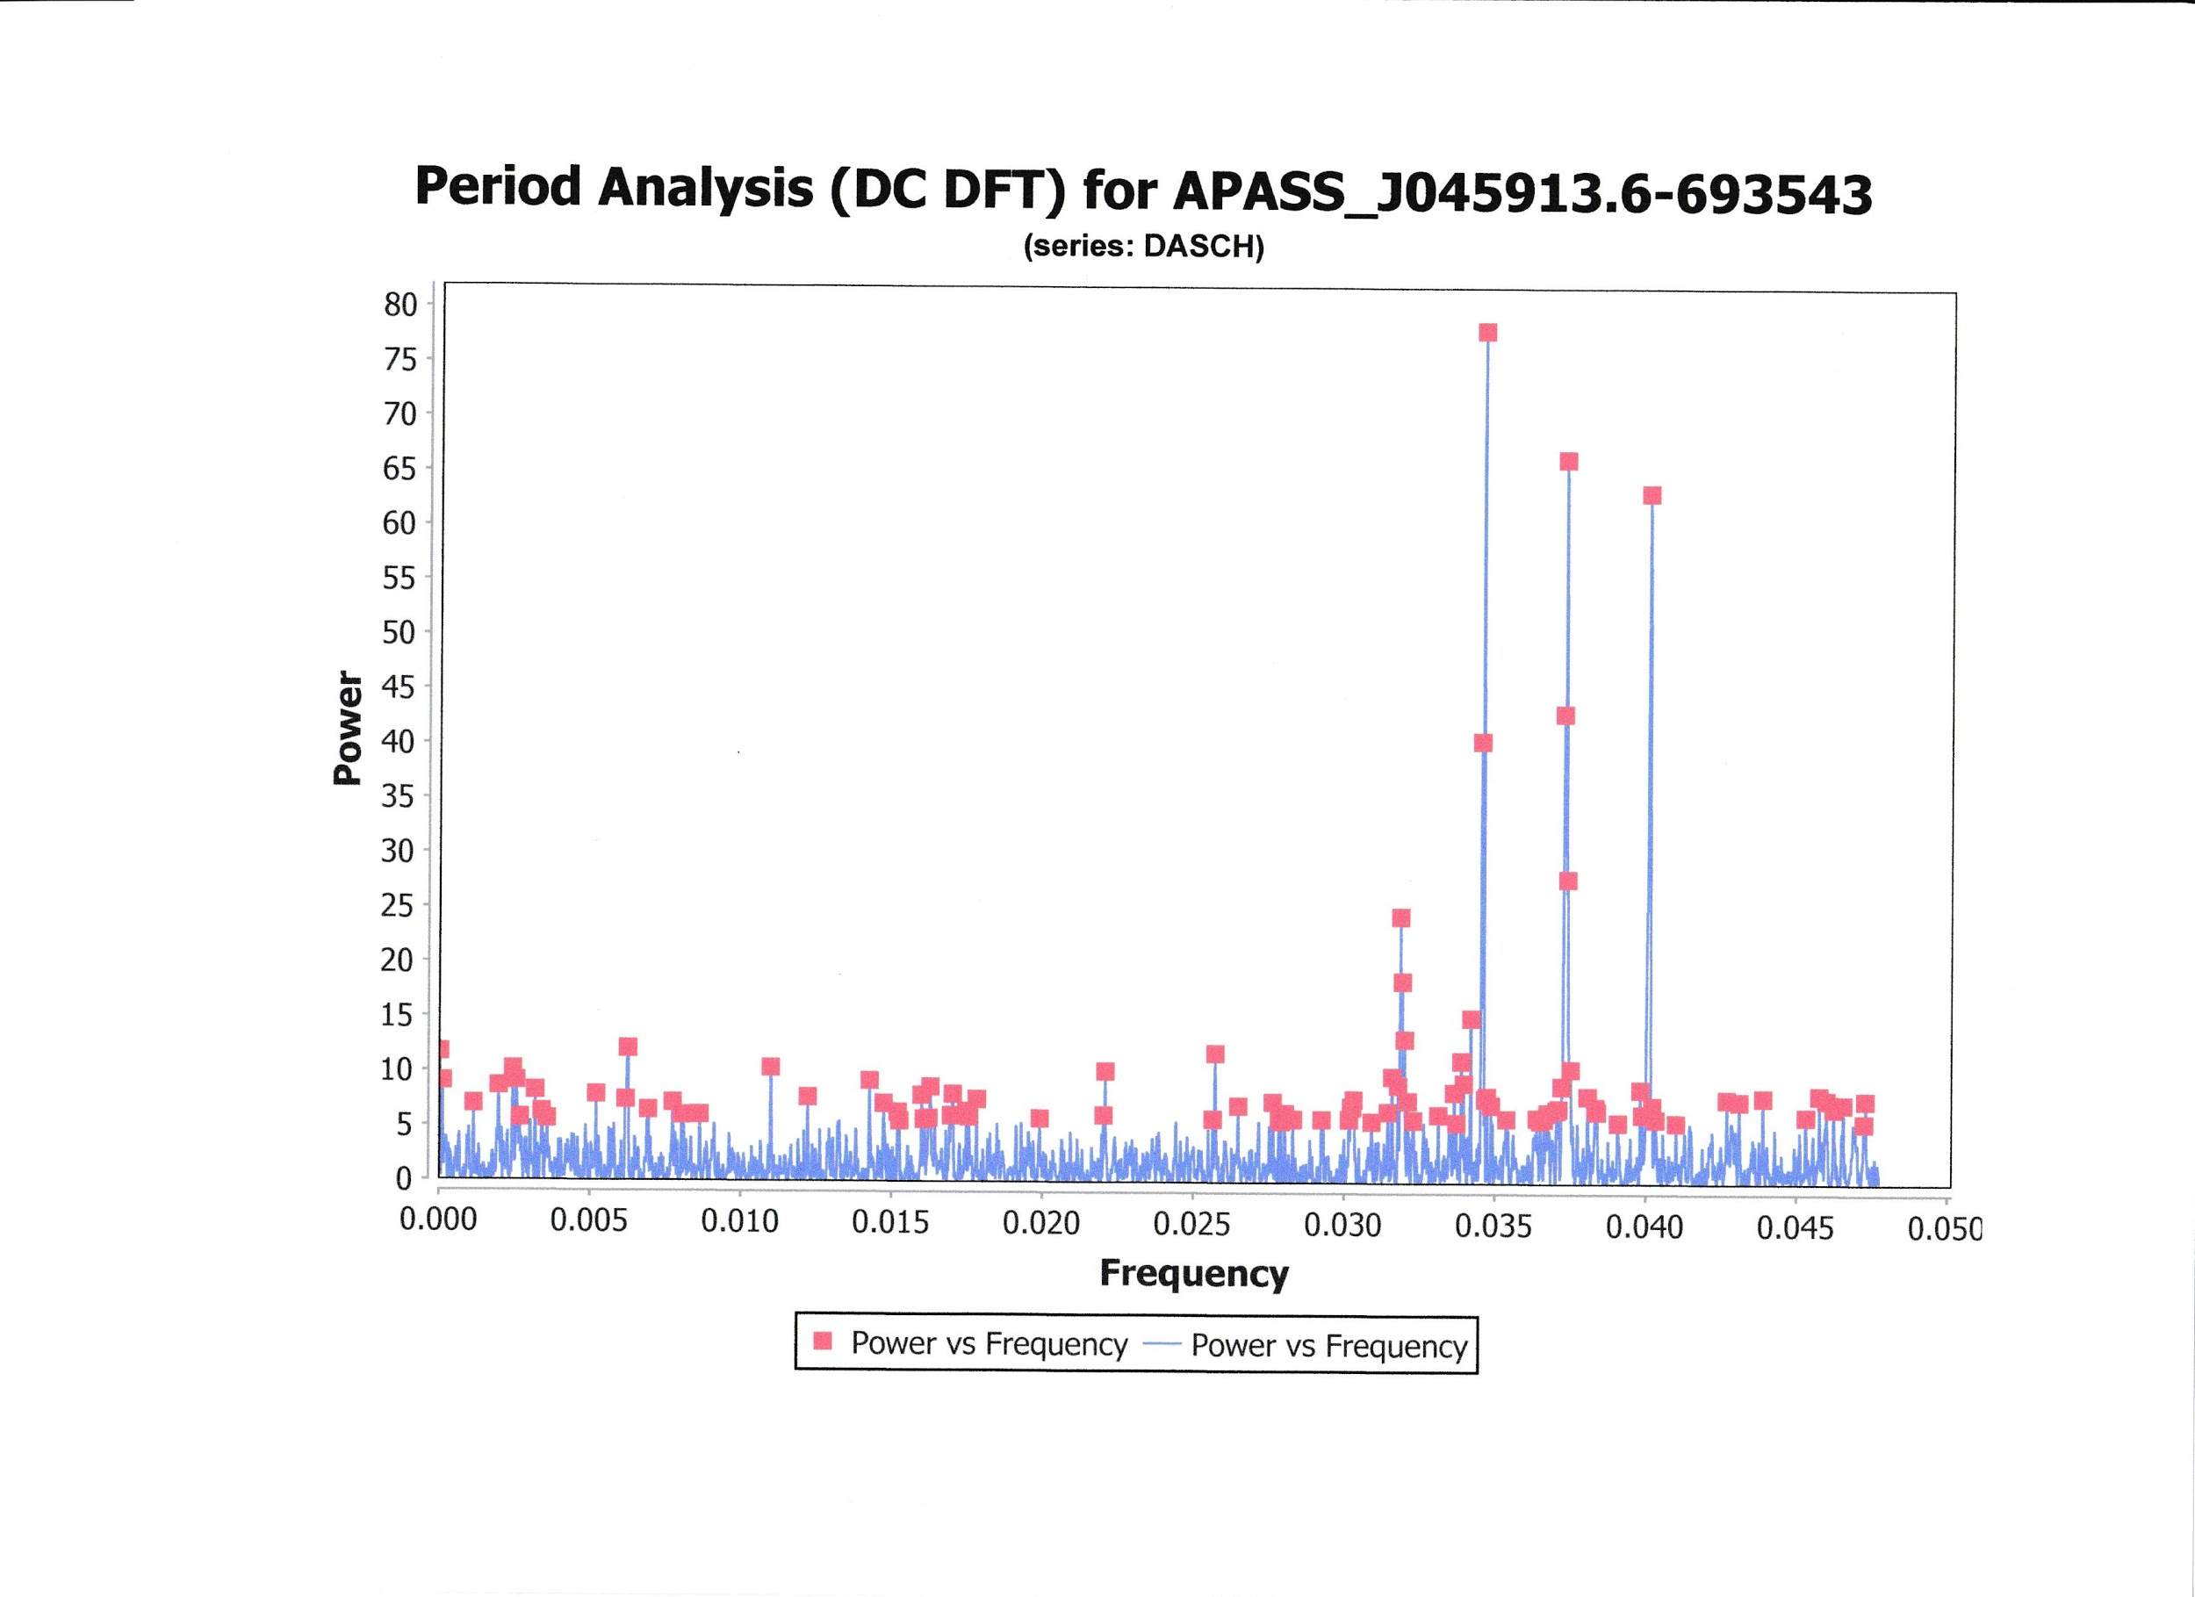

Selecting the “Top Hits” option will yield the following phase plot.

